Ernst Mayr Library News August 2019
Connie Rinaldo and Mary Sears

Tours and Classes. If you are new on campus or are just starting a new project, a tour of the library might help! Library tours, research consultations, and group/class sessions are all available upon request. We can arrange for a class visit to the Library or send a librarian to your class or lab section. Drop by the library or email us to make an appointment.

HOLLIS updates

A year after the rollout of the new Hollis library system, most of the initial problems have been resolved and a new set of features have been introduced. For assistance using Hollis, contact us at mayrlib@oeb.harvard.edu or check the HOLLIS User Guide.

List of versions (for the same title). When Harvard has a print copy and also licenses the online version of a book or journal, there are separate records in Hollis. Instead of the same title appearing several times in a result set, the records are grouped together, with a message in brown text at the top. Click on “Check for online access...” to see the list of versions that belong to the same publication.

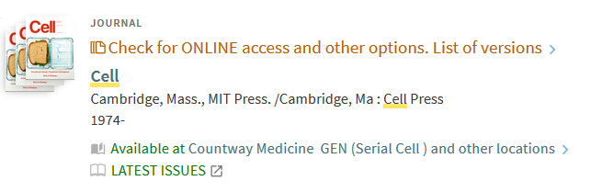
The Latest Issues link is another update. It can save time if you just want the pdf of a very recent article. Not all journals in Hollis have the Latest Issues link, only those covered by the Browzine service. More on Browzine below.

“Map-it” Location details. Books, etc., at Widener, Lamont and Law now show details about where to physically locate the item: library name, floor and row number. Click on the “Map it” link to see a map of the stacks. (Not yet available for Ernst Mayr Library.)

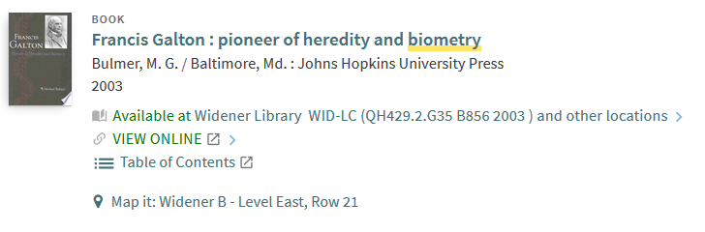

BenchSci is a new search platform, free to Harvard affiliates. BenchSci searches journal articles by protein, gene, clone ID and identifies relevant figures. Review figures and connect to full-text articles; review products used in the figures and connect with the vendors. Sign up for a free account with your Harvard email. Maurice Shen from BenchSci visited Science Libraries Council in June for a demonstration. More info on their blog.

Browzine is a current contents tool, connected to full-text articles. Sign up for a free Browzine account with your Harvard email and build a virtual bookshelf of your favorite journals.

Citation Tools. The library recommends Endnote and Zotero, though Harvard supports other citation tools. Classes on Endnote and Zotero start in September! Click for more info or to register.

DASH. Digital Access to Harvard Scholarship is an open-access repository of works by Harvard authors, including graduate dissertations. Faculty, students and staff can deposit articles or send the DASH staff their publication list. DASH is part of the Harvard Library Office for Scholarly Communications, which can advise on copyright and publishing issues.

Getting the Full Text. Try the Full-text tools that work with Hollis and Harvard’s journal subscriptions. The Lean Library browser extension, customized Google Scholar settings and the Check Harvard Library bookmark simplify your Harvard Key access to online full-text.

Translations. Harvard does not currently have a translation service. However, for Chinese, Japanese and Korean, there are students and staff who may be able to help. Contact Rebecca Mahoney, program coordinator in the Dept. of East Asian Languages and Civilizations, who can post your request. Please include a brief description of the document to be translated, and whether the work would be paid.

Is the library open? Click for today’s hours.

For more information, please visit the Ernst Mayr Library website
email us at mayrlib@oeb.harvard.edu or call 617-495-2475.

