The Ernst Mayr Library is pleased to announce a new way to interact with our Special Collections and Archives. In addition to email, phone and in-person inquiries, library users can now request materials in advance through Hollis.
This system is now in place in several libraries on campus, including the Botany Libraries, Tozzer and Houghton.
The Special Collections Request System allows patrons to register and place requests for materials online. Upon registering, an individual account is created. With that account a patron can:
• submit requests through a form or submit requests via links in the catalog record
• submit requests in advance of a visit to Special Collections or while in the library
• submit requests for photoreproduction of Special Collections materials
• track the status of each request
• access detailed information about past requests
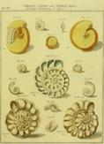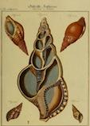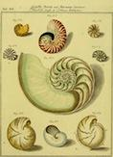

Hollis users will now see the Request Item link when searching for Ernst Mayr Library rare books and archives.

Clicking on the Request Item link leads to the login prompt:

Ernst Mayr Library Special Collections materials must be used on site (no change in policy).
For more information, please contact Robert Young, Special Collections Librarian, ryoung@oeb.harvard.edu .

