Wild Turkeys Roosting at the Museum
Visitors to the Ernst Mayr Library are greeted by John James Audubon’s 1826 painting of Wild Turkey Cock, Hen and Nine Chicks.
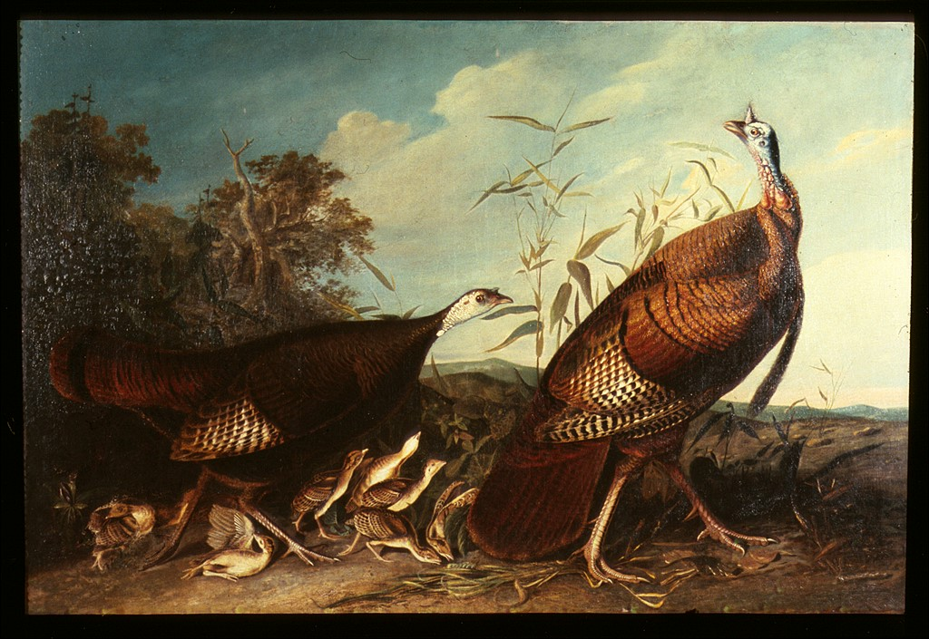

Library staff often observe wild turkeys (Meleagris gallopavo) strolling around the Harvard campus. They are typically ground birds, as depicted in the painting, but can fly for short distances.
On a recent early spring morning, a dog startled a flock of turkeys up to trees and rooftops behind the Museum of Comparative Zoology.

